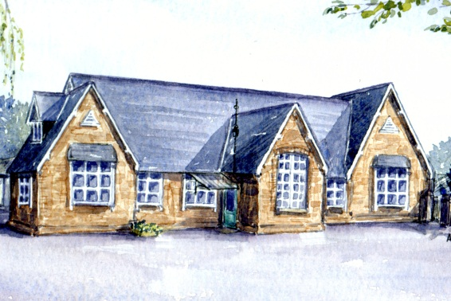 n

**Stickney Church of England Primary School**

**“LEARN, ENJOY, ACHIEVE”**

**Executive Headteacher: Mrs R. Thompson**

**Main Road, Stickney, Boston, Lincolnshire, PE22 8AX**

**Telephone: 01205 480254**

**Email: enquiries@stickney-pri.lincs.sch.uk**

**www.stickneyprimary.co.uk**

9th April, 2020

Dear Parents/Carers

**Free School Meals**

We hope that you and your families are all staying safe during this unusual and difficult period.

We know many of you will be anxious about your jobs and finances as this pandemic continues to cause uncertainty to many industries and the economy as a whole.

As you may be aware Free School Meals are available to families on low incomes who receive certain benefits. These include:

Universal Credit  
Income Support  
Income-Based Job Seekers Allowance  
Income-related Employment and Support Allowance  
Support under Part VI of the Immigration and Asylum Act 1999  
Child Tax Credit (provided you’re not also entitled to Working Tax Credit and have an annual gross income of no more than £16,190.  
Working Tax Credit run-on paid for four weeks after you stop qualifying for Working Tax Credit.

If your circumstances have changed, or you find that they change in the future, please apply for Free School Meals online using the following link, <https://www.lincolnshire.gov.uk/school-pupil-support/apply-free-school-meals> , or simply search for Lincolnshire County Council, Free School Meal Application. On your application, please ensure that the full name used matches that linked to your National Insurance Number (i.e.maiden name, if that be the case.)

**Please note that grocery vouchers are being provided to families who receive Free School Meals even if their children are not attending school during the Government lockdown.**

We hope this may go a little way to easing the burden for families at this time.

Yours sincerely

Mrs Rowena Thompson

Executive Head Teacher